**University of Petroleum and Energy Studies**

School of Computer Science

Department of Cybernetics



**Graphics & Animation Tools**

**LAB FILE**

**(Session: 2020-2021)**

Course: B. Tech with Specialization in Open Source and Open Standards

Batch: 2017-2021

Semester: VIIth

**Submitted To: -**

Dr. Durgansh Sharma

Assistant Professor

Department of Cybernetics

**Submitted By: -**

Nikhil Mishra

Roll No: R100217043

SAP ID: 500062584

**VIVA-ASSIGNMENT**

**1) Aim:** Create a Mobile Phone using GIMP

**Steps followed**:

1. Open GIMP.
2. Inside gimp, create a new layer with white background (1080x1080 px).
3. Open an image of smart phone as layers in GIMP and create a new transparent layer to draw boundaries.
4. Use the ‘Paths tool’ over the image and start selection boundaries and layout of the image.
5. After selection of layout/ boundaries, go to ‘Select’, choose ‘From Path’ option and your path will be selected.
6. After path is selected click on ‘bucket fill tool’ from the toolbar and colour the smartphone with your desired colour.
7. Repeat step 3,4,5 for creating the base, front and screen of the smart phone.
8. Structure of smartphone is complete, now go to ‘Text tool’ and write name of the brand that you want for your phone.
9. Use your creativity to style your text and when you feel it’s good, then place is at the desired location.
10. For adding the app icons and notification panel on top, use rectangle selection tool and ellipse tool for creating rectangle icons and circular icons.
11. For creating battery percentage on top right, go to ‘Text tool’ and write number, adjust size and location of it.
12. Additional: For creating time widget, cut the image and place it on the desired location i.e. centre.

**Output:**

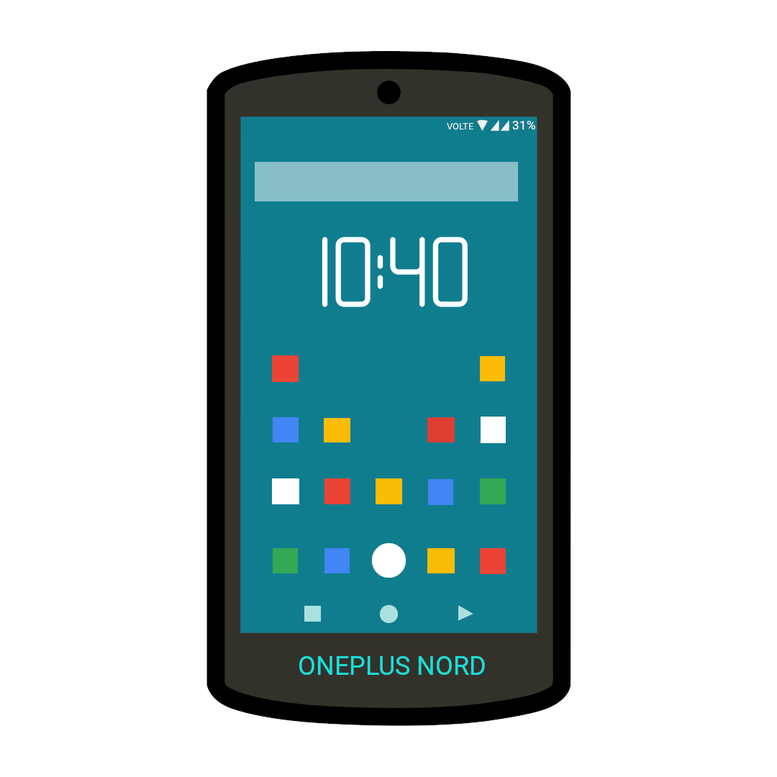

**2) Aim:** Create a fruit basket or set of fruits using blender.

**Steps followed:**

1. Open Blender, and clear everything from the interface which are already there.
2. For apples, take the sphere from the mesh and give it a grouve from above so, that it looks like the upper portion of apple. Now, put some dots on the apple to give it more realistic look.
3. Now, take the upper portion of apple and extrude it a bit to give the shape of twig which is attached with the apple.
4. Repeat step 7 and 8 multiple times to create an apple and similarly create pumpkin.
5. For banana, go to mesh and take a plane area and then go to mesh again and select a cylinder.
6. Stretch the upper face with respect to base of cylinder and give it a shape of banana.
7. Extrude the surfaces from all the sides at equal distance to give it a look of moulded surface of banana.
8. Extrude the bottom of the surface around 1.5 pts and give it shape of base of the banana top.
9. Do a few changes in the model of banana to give it a realistic approach in better ways.
10. Now, go to shading and then random and fill your selected area with random colours.
11. Add camera and point surface light for rendering of our model.
12. Go to file and save it as your name and render a few pictures for the display.

**Output:**

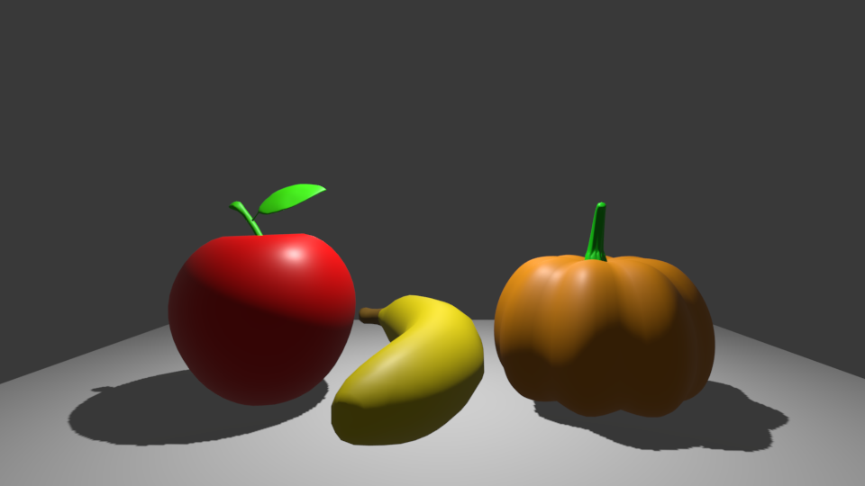

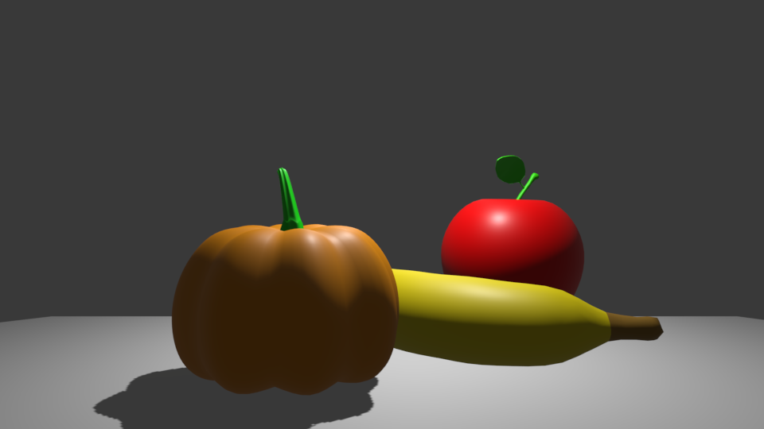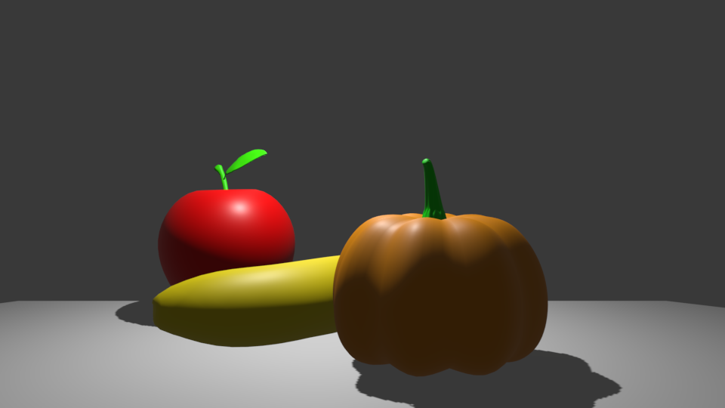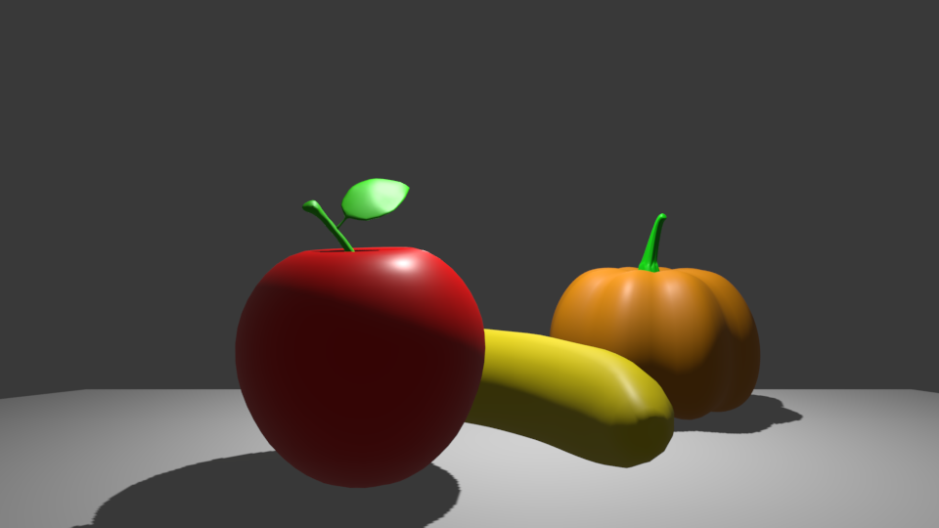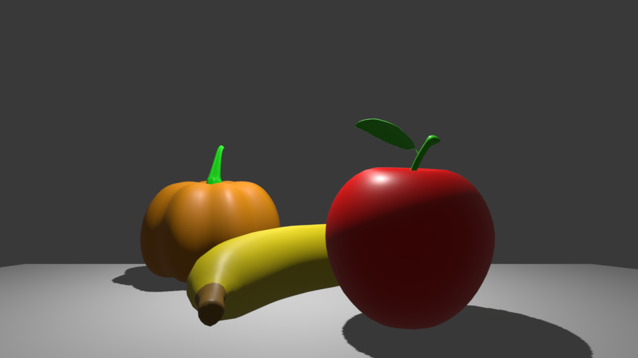

**Drive Link:** <https://drive.google.com/drive/folders/18C0VtIAk-awUy3Axst3degZLR7YdXza2?usp=sharing>